# CS 255 – Project Two - System Design Document

Jason Barry

Professor Venckus

CS-255-11329-M01 System Analysis and Design

19 June 2024

## UML Diagrams

### UML Use Case Diagram

This diagram helped visualize the various user roles that would interact with the system. The use case diagram also helped reduce redundant roles such as the IT officer (which performs the same actions that a system administrator usually does).

### UML Activity Diagrams

**Activity Diagram 1 – Customer Role - Logging In**

This diagram visualizes how the customer role interacts with the system by showcasing the steps they take to log in to the system.

**Activity Diagram 2 – Customer Role - Managing Appointments**

This diagram visualizes how the customer role interacts with the system by showcasing the steps they take to manage their appointments. The diagram assumes the customer was already logged in via the actions taken in the previous diagram.

### UML Sequence Diagram

**Sequence Diagram – Customer – Logging In**

This diagram helped showcase that two databases are required to validate user information and track the number of login attempts.

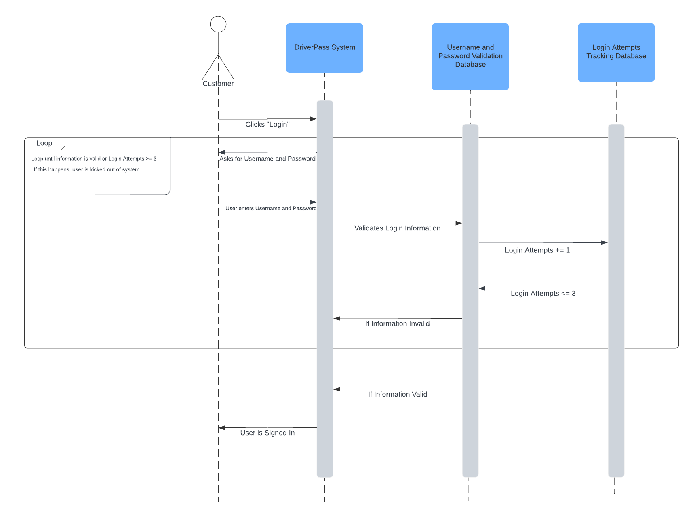

### UML Class Diagram

While more accurate methods and attributes will be discovered throughout the development process, this diagram helps showcase the various classes and attributes the system will need

## Technical Requirements

**Hardware Requirements for Host:**

To successfully operate the system, the host must either have access to a physical server or utilize a cloud service provider. If using a physical server, more than one server should be utilized. The additional servers will serve as backups to the primary server. Furthermore, the host server must utilize networking cables to successfully connect to the internet. On a similar note, to ensure these servers work as intended, they must be connected to a power source. Additionally, to ensure the host may interact with the server, interaction tools (including a monitor, keyboard, and mouse) should be utilized. Meanwhile, if using a cloud service provider, a provider must be selected. All in all, these hardware requirements are necessary for the host to “host” the system online.

**Hardware Requirements for Client:**

To access the system, the client must have access to a desktop or personal computer. If using a desktop, the user must utilize tools (including a monitor, keyboard, and mouse) to interact with the system. Furthermore, because an internet connection is required to access the system, the client must utilize either a wireless card or an ethernet cable. When combined with a power source, these resources will allow the client to access the system.

**Software Requirements for Host:**

For the host to successfully operate the system, they must utilize *Mac, Linux,* or *Windows* as their operating system. The host must also have access to the *DriverPass* system. Access to this software will allow the host to “host” the software online using their aforementioned physical servers. Lastly, the host must utilize security software to ensure sensitive information is protected from external threats.

**Software Requirements for Client:**

For users to successfully access the system, they must utilize *Mac, Linux,* or *Windows* as their operating system. If this condition is met, the user must also utilize a web browser application such as *Chrome, Firefox,* or *Explorer.* Lastly, because the system is hosted from an online server, the user must have an internet connection.

**Tools for Development:**

The development of the required system for *DriverPass* requires multiple tools for development. For example, the development team must have access to computers that have access to programming software (such as *Visual Studio* or *Eclipse*). These computers should possess an internet connection that enables server uploads. Lastly, for security purposes, network admin tools must be used to watch out for suspicious traffic

**Infrastructure Required:**

The development of the client’s system carries the prerequisite that certain infrastructure requirements are met. For example, a physical server location and/or a cloud service provider is a necessity. If using a physical server, this location must provide the adequate supplies necessary for powering the server and connecting the server to the internet. In addition, even if a cloud provider is utilized, the system necessitates an adequate upload speed. Furthermore, the development company must decide if its developers will work on the system remotely or at a physical location. If the developers will work on the system at a physical location, a building must be purchased/rented and parking spaces must be provided. Lastly, to ensure the system enables online transactions, a contract with a credit card processing company must be acquired.